Information Services

Adobe Sign-In User’s Guide
Adobe Sign-In v1.0

Adobe Sign-In User’s Guide
Adobe Sign-In v1.0
Table of Contents
Purpose 3
Steps 3

Adobe Sign-In User’s Guide
Adobe Sign-In v1.0

Purpose
The following document details the steps required to leave the Adobe ‘Creative Cloud’ account and enable your UF Enterprise ID.

Steps
- If prompted by Adobe Creative Cloud to update, don’t.
- If the install has started, stop creative cloud by clicking Cancel.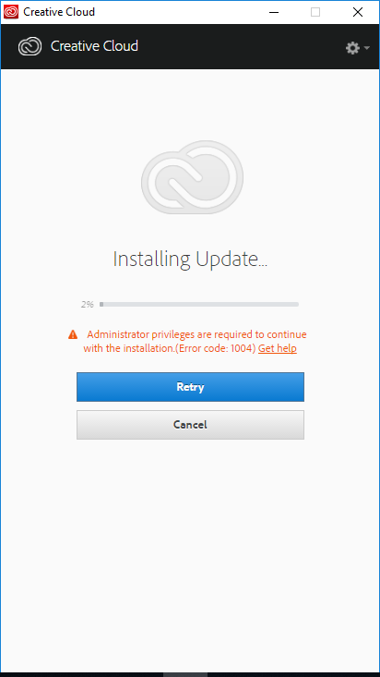

- Then close creative cloud, by clicking Quit.
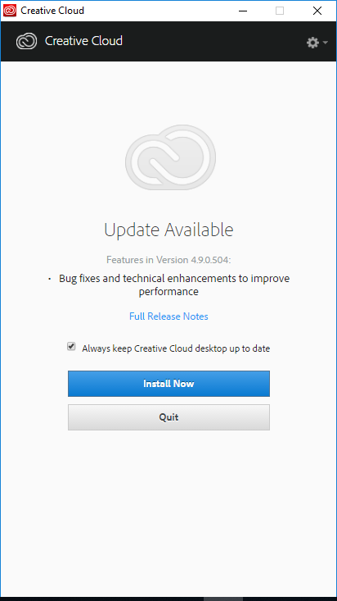

- Then open Adobe Acrobat and Sign Out by going to the Help menu.
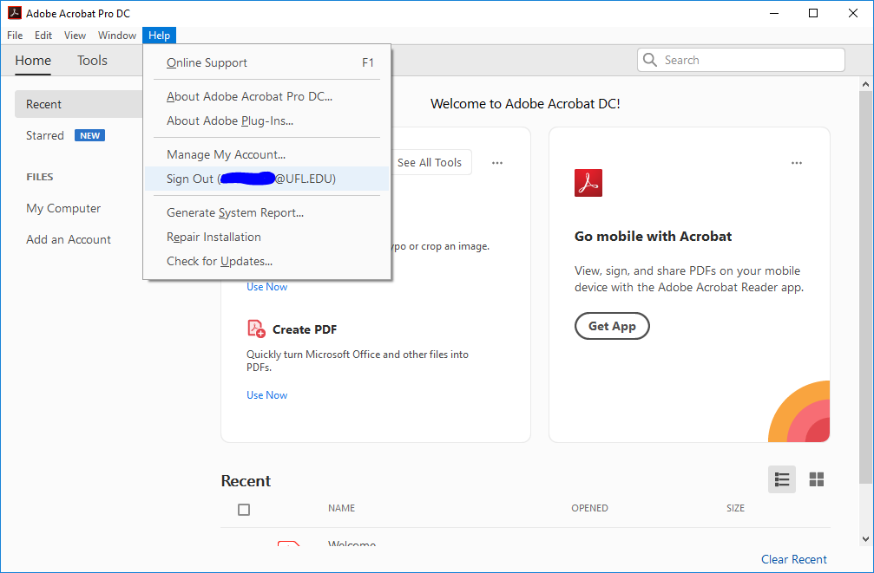

- Confirm your Sign Out by clicking Sign out.
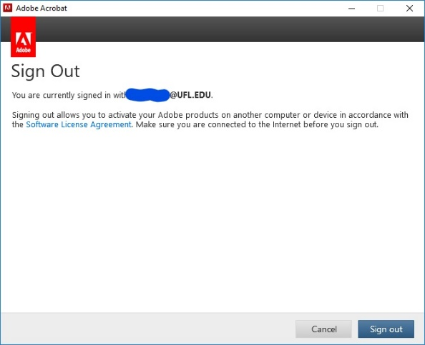

- Close Acrobat, then reopen Acrobat.

- Click Sign In Now.
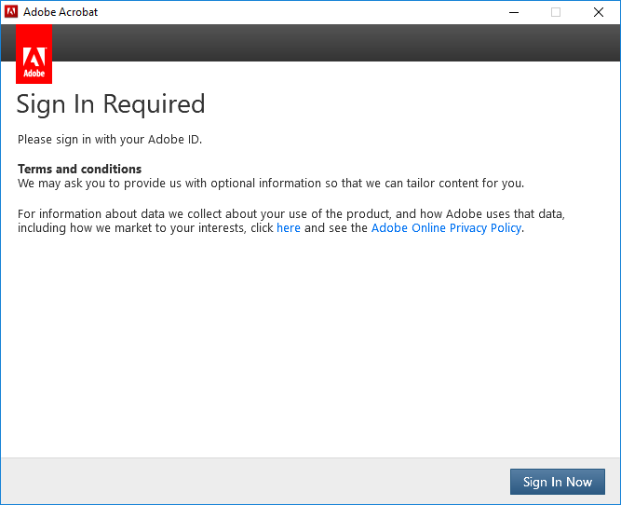

- Enter in your username@ufl.edu email address. This will automatically open the next dialog.
TT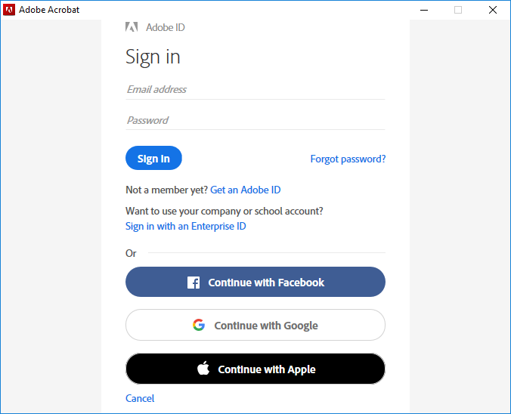

- Select Enterprise ID.
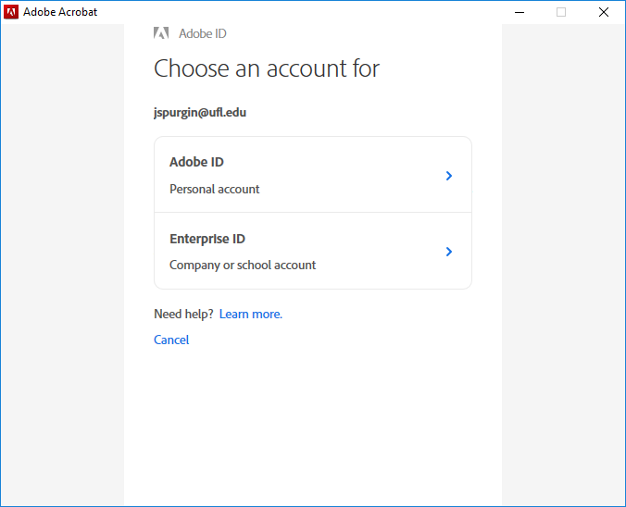

- Sign in with your Gatorlink Username and Password. You will need your 2FA device.
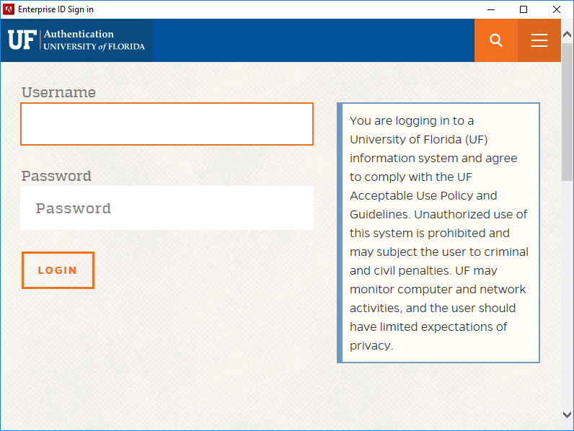

- Click Continue and Adobe Acrobat will open.
